Library Management System

Summer Internship Report

Submitted to

**Sharda University**



In partial fulfilment of the requirements of the award of the

# Degree of Bachelor of Technology

in

Page

|

**1**



**Computer Science and Engineering**

by

**Ankit Kumar Deo (2021370540)**

Under the mentorship of

**DR. RANI ASTYA**

Department of Computer science and

Engineering

School of Engineering & Technology

Sharda University

Greater Noida

October, 2023

**DECLARATION OF THE STUDENT**

We hereby declare that the project entitled is an outcome of our own efforts under the guidance of Dr. Rani Astya. The project is submitted to the Sharda University for the partial fulfilment of the Bachelor of Technology Examination 2022-23.

We also declare that this project report has not been previously submitted to any other university.

**Ankit Kumar Deo (2021370540)**

--------------------------------

# CERTIFICATE

This is to inform that **Ankit Kumar Deo** of Sharda University has successfully completed the project work titled Library Management System Search in partial fulfilment of the Bachelor of Technology Examination 2022-2023 by Sharda University.

This project report is the record of authentic work carried out by them during the period from JULY 2023 to DECEMBER 2023.

-------------------------------

**Ankit Kumar Deo (2021370540)**

------------------------------------------------

Dr. Rani Astya

Assistant Professor,

Computer Science & Engineering (CSE)

------------------------------------------------

Dr. Sanjeev Kumar Pippal

Professor & Head of the Department,

Computer Science & Engineering (CSE)

ABSTRACT

With the advancement of technology, it is imperative to exalt all the systems into a user-friendly manner. The Library Management system (LMS) acts as a tool to transform traditional libraries into digital libraries. In traditional libraries, the students/user has to search for books which are hassle process and there is no proper maintenance of database about issues/fines. The overall progress of work is slow and it is impossible to generate a fast report. The librarians have to work allotted for arranging, sorting books in the book sells. At the same time, they have to check and monitor the lend/borrow book details with its fine. It is a tedious process to work simultaneously in different sectors. LMS will assist the librarians to work easily. The LMS supports the librarians to encounter all the issues concurrently. The users need not stand in a queue for a long period to return/borrow a book from the library. The single PC contains all the data’s in it. The librarians have to assess the system and provide an entry in it. Through LMS the librarian can find the book in the bookshelves. The LMS is designed with the basic features such as librarian can add/view/update/delete books and students' details in it. Once he/she ingress into the system they can modify any data’s in the database. The complete model is developed in Dot net technology, the C# language is used to build the front end application whereas the SQL server is exploiting as database. The authorized person can only access the LMS system, they have to log in with their user id and password. As aforementioned that the LMS is designed in a user-friendly manner, so the admin can smoothly activate the system without expert advice. Every data is storing and retrieving from the SQL database so it is highly secure. Thus our system contributes its new approach towards the digital library setup.

# ACKNOWLEDGEMENT

I would like to express my deepest appreciation to all those who provided me the possibility to complete this report. Apart from the efforts of myself, the success of any project depends largely on the encouragement and guidelines of many others. I take this opportunity to express my gratitude to the people who have been instrumental in the successful completion of this project. I would like to show my greatest appreciation to **Dr. Rani Astya**. I cannot say thank you enough for her tremendous support and help. I feel motivated and encouraged every time i attend her meeting. Without her encouragement and guidance this project would not have materialized. The guidance and support received from all the members who contributed and who are contributing to this project, was vital for the success of the project. I am grateful for their constant support and help. Besides, I would like to thank the authority of Sharda University for providing mw with a good environment and facilities to complete this project. Finally, an honourable mention goes to our families and friends for their understandings and supports on me in completing this project. Without helps of the particulars that mentioned above, I would face many difficulties while doing this.

**TABLE OF CONTENTS**

|  |  |  |
| --- | --- | --- |
| **Sr. No.** | **Contents** | **Page No.** |
|  | Title Page | i |
|  | Declaration | ii |
|  | Certificate of the Guide | iii |
|  | Abstract | **iv** |
|  | Acknowledgement | **v** |
| 1 | **INTRODUCTION**   1. Problem Definition 2. Hardware Specification 3. Software Specification 4. Motivation 5. Objectives 6. Contributions 7. Summary | 7 |
| 2 | **LITERATURE SURVEY**  1. Related Work Summary | 13 |
| 3 | **DESIGN AND IMPLEMENTATION**   1. Methodology 2. Design 3. Implementation   Summary | 15 |
| 4 | **RESULT AND DISCUSSIONS**   1. Results 2. Discussion Summary | 20 |
| 5 | **CONCLUSION**   1. Conclusion 2. Future Scope Summary | 27 |
| 6 | **REFERENCES** | 30 |

## INTRODUCTION

A library serves as a repository of knowledge and resources accessible to users, functioning as the intellectual hub of educational institutions. It plays a pivotal role in fostering the spread of knowledge and cultural development among students. The vast array of books and research materials captivates students, encouraging them to expand their knowledge across various disciplines. This wealth of information guides students to articulate their perspectives effectively, optimizing academic performance and personal skill development. However, the evolving landscape of technology has spurred the need to transition from traditional to digital library setups.

The traditional library, characterized by manual processes, faces inefficiencies that hinder its effectiveness. Tasks such as cataloging books, tracking details on paper, and managing distribution are time-consuming and prone to errors. The Library Management System (LMS) emerges as a solution to propel libraries into the technological era. It automates tasks with a single click, alleviating the workload of staff and librarians. The LMS efficiently manages, organizes, and streamlines library operations, allowing librarians to add, view, delete, and update details seamlessly. Integration with the SQL server centralizes all library data.

The system begins with the librarian adding student and book details to the database, facilitating subsequent viewing, deleting, and updating through the LMS. Users can access the library anytime, obtaining information without resorting to paper references. Librarians can easily navigate the system, retrieving data without confusion. The LMS displays user details, including username, ID, book information, and penalty details. Its user-friendly interface requires only basic computer knowledge, making it accessible to all. Additional features include record maintenance, tracking student penalty history, and monitoring book counts and issued book details. This flexibility benefits both librarians and students.

The LMS, presented with an Admin module, is built on .Net Technology, recognized as a cutting-edge technology in the IT industry. Data is securely stored and organized in the database, allowing users to create customized databases as needed. The Database Management System (DBMS) facilitates interaction with the database, receiving commands from administrators to load, retrieve, or modify data. Centralized DBMS ensures controlled access for multiple users at different locations, offering both logical and physical data independence. Open Database Connectivity (ODBC) provides an interface for client-side programs to interact with the server-side DBMS, enhancing accessibility and functionality.

### 2. Hardware Specification

Hardware Requirements: The application requires a minimum hardware setup for proper functioning, including:

a) Operating System: Windows

b) Hard Disk and RAM: A minimum of 40GB and 4GB, respectively

c) Processor: Dual-Core CPU

Web Servers:

Server Type: Virtual Private Servers (VPS) or cloud-based instances.

Processor: Dual-core or higher.

RAM: 8GB or more.

Storage: 100GB SSD or higher for the operating system and application.

Operating System: Linux (e.g., Ubuntu, CentOS).

Web Server Software: Nginx or Apache.

1.1 SQL DATABASE

SQL, also known as Standard Query Language, serves as a communication medium with the database. SQL statements execute queries, retrieve data, and enable actions like creating databases, tables, stored procedures, and updating or deleting items. Permissions for viewing, procedures, and tables can

**RELATED WORK**

Shasha and colleagues [1] conducted research on enhancing library management systems to meet the increasing demand from students. Honghai et al. [2] proposed a paper addressing the inefficient investment in CDs attached to books, suggesting cost-saving through cloud computing for data transfer. Bao et al. [3] presented a paper constructing a prediction model for libraries, focusing on the strong relationship between lending and the number of readers. Their analysis concentrated on library lending for designing a model library. Eraxiang et al. [4] highlighted the disadvantages of traditional library management systems and proposed a solution using the struts and hibernate framework in MVC architecture, enhancing maintainability and reuse.

Zheng et al. [5] introduced a paper based on UML for the Library Management System, designing and modeling the LMS based on UML concepts. Hitchense et al. [6] proposed a paper advocating flexible class usage, suggesting class reuse for similar conditions. Yang et al. [7] addressed the tedious manual work of librarians by introducing an LMS through VB. Bretthauer et al. [8] discussed open-source software for libraries, explaining both its benefits and drawbacks. Brave et al. [9] presented various open-source software for libraries, including LMS, digital library software, content citation and knowledge, and journal management software. Albee et al. [10] examined staff satisfaction and attitudes towards open-source libraries. Singh et al. [11] compared expectations and experiences of open-source libraries, while Huang et al. [12] proposed a paper for learning SQL databases to enable students to test the functionality of SQL statements.

To enhance the design and progress of library management systems, we presented an LMS in .Net technology, easily accessible by librarians, overcoming drawbacks of existing methods. The system ensures high security and provides effective results to users. The subsequent sections of the paper are organized as follows: Section 3 briefly describes the architecture of the proposed system, and Section 4 explains the conclusion of the system.

**Methodology**

**3.1**

**Block Schematic**

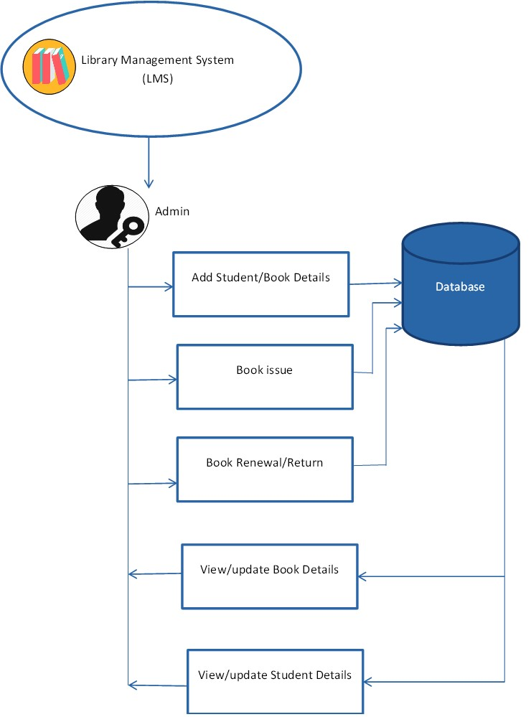

Fig 3.1: Block Diagram of Proposed system

Fig 3.1 illustrates the block diagram of the envisioned Library Management System (LMS). This system comprises an Admin module that showcases the activities undertaken by the administrator. The administrator is the authorized individual with access to the LMS system, entering through a designated user ID and password. Upon logging in, the system initializes and displays the Home page, as depicted in Fig 3.2. On this page, the administrator is prompted to input their ID and password for authentication.

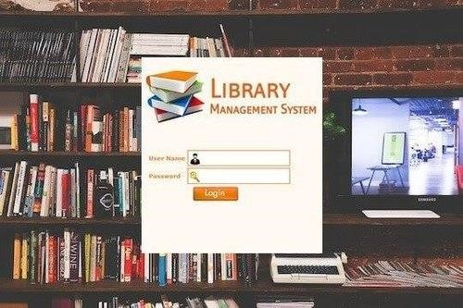

Fig 3.2: Login Page of Library Management System

After successfully logging into the system, the administrator gains access to various functions for managing the library. The Admin has the capability to add and modify data within the system. This includes the ability to add student and book details, issue books, facilitate book returns, as well as view and update information related to both books and students. The Admin essentially holds the authority to perform key tasks in the library system, ensuring efficient management of student and book records.

Fig 3.3: Adding students to LMS

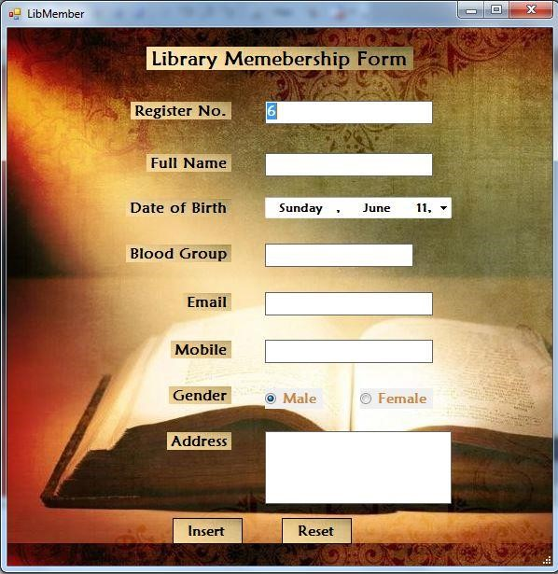

In the Library Management System (LMS), when adding student details, the enrollment process involves recording essential information such as register number, name, date of birth, blood group, email ID, mobile number, gender, and more. Similarly, when adding a new book to the system, the enrollment procedure includes capturing details like book ID, author name, number of copies, price, and other relevant information. Fig 3.4 provides a visual representation of this data entry process, outlining the fields and information required for both student and book enrollment in the system.

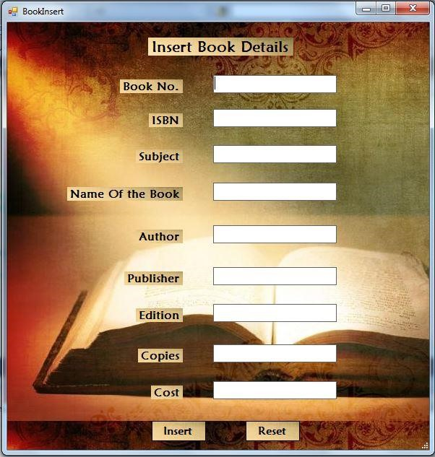

Fig 3.4: Adding new book to LMS

The data added by users can be managed through the Admin module, providing the Admin with the capability to view, update, and delete information. Specifically, the Admin can view and search for any book within the Library Management System (LMS) using the search option, as depicted in Fig 3.5. This functionality allows for efficient retrieval and management of book details within the system.

Fig 3.5: Searching book details in LMS

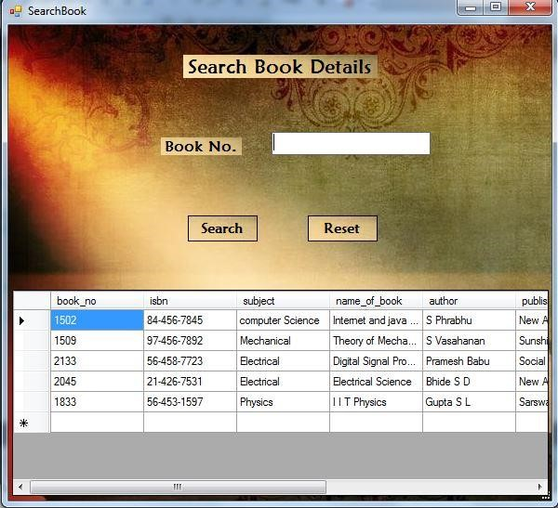

The Library Management System (LMS) was implemented using .Net for the front end and SQL for the back end. In the previous system, users had the potential to illegitimately alter entry dates, as the entries were recorded in a notebook that allowed overwriting. The existing system posed challenges for librarians, but the LMS has addressed these issues, providing a user-friendly environment for enhanced library management. This advancement has significantly accelerated progress in the library, attracting more patrons. Additionally, the risk of missing books can be mitigated by thorough verification of the database, encouraging librarians to maintain and check it meticulously. The LMS system surpasses the drawbacks of the previous system, enabling librarians to work efficiently and quickly. All details are consistently updated in the LMS, facilitating easy verification of book information. The cumbersome nature of the earlier system has been eliminated, promoting a user-friendly environment for librarians and elevating library management to a new level.

## Database Design

Database design serves as a mechanism for managing data duplication and involves creating a comprehensive data model for a database. This model encompasses the necessary conceptual, logical, and physical storage parameters essential for designing the database using a Data Definition Language (DDL), primarily used to create databases. In a fully attributed data model, every entity possesses complete attributes.

The process of database design typically involves multiple stages, guided by database designers. Designers generally follow a set of procedures, including

**Conceptual Design**

The conceptual design stage aims to build a conceptual model that aligns closely with the final physical model based on previously identified requirements. A widely utilized conceptual model is the Entity-Relationship (ER) model, often represented through an Entity-Relationship Diagram (ERD). An ERD is a popular high-level conceptual data model, providing a comprehensive and logical illustration of data or an organization within a business area. This model is crucial for mapping the meanings and interactions of real-world entities onto a conceptual schema.

## The ERD (Fig.1) presented below illustrates the entities in the Library Management System (LMS), the relationships among these entities, and the attributes of both entities and their relationships. It serves as a descriptive tool for all data involved in the system—capturing input, storage, transformation, and output. The ERD focuses specifically on data objects, their attributes, and the relationships that interconnect various data objects within the LMS.

## 

fig 1 : Conceptual design

**Logical Design**

The logical design phase involves structuring data into a series of logical relationships, referred to as entities and attributes. An entity represents a distinct piece of information, and in the context of a relational database, it often corresponds to a table. On the other hand, an attribute is a component of an entity that helps define the uniqueness of that entity. In a relational database, an attribute typically maps to a column, while an entity maps to a row. This process of organizing data into entities and attributes forms the foundation for the logical structure of a database, facilitating efficient storage, retrieval, and manipulation of information.

**Physical Design**

During this phase of design, the plan on how to build the tables, including appropriate data, types, field sizes, attribute domains, and indexes are described. The plan must express adequate details of the relevant fields that anyone can understand and use this plan to build a database. For this project, indexes and attribute domains are excluded from the physical design.

## The conceptual design and logical design were independent of physical considerations. We are focusing on relational model and on creating database management system (DBMS) using MySQL, although our main focus is on those physical considerations.

## Architecture Design

The phase of designing computer and software architecture is referred to as high-level design. In selecting the architecture, the model needs to encompass a comprehensive list of modules, concise functionalities of each module, their interface relationships, dependencies, database tables, architecture diagrams, technology details, and more. The design also involves assimilation testing, as specified in [12]. After determining the system requirements, the essential specifications for hardware, software, data resources, and information products that will fulfill the functional requirements of the proposed system can be established.

As depicted in Fig.2, this design serves as a blueprint for the entire system, aiding in the identification and management of connections between different sections. It provides a roadmap for understanding and organizing the various components that contribute to the overall architecture and functionality of the system.

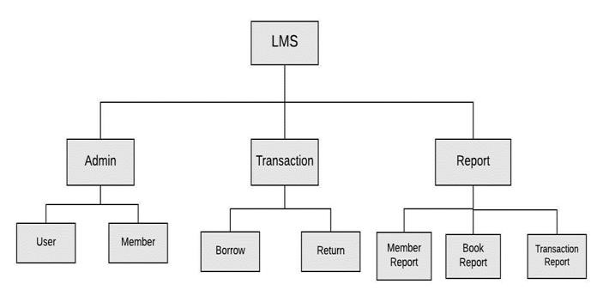

Fig 2 : Architecture Design

## Interface Design

## User Interface (UI) Design is centered on anticipating users' actions and ensuring that the interface incorporates features that are easily accessible, understandable, and user-friendly for facilitating those actions. This design phase integrates concepts from visual design, interaction design, and information architecture to create an interface that enhances user experience.

## Module design

At the module design level, often referred to as low-level design, the intended system is broken down into smaller units or segments, with each unit being thoroughly explained. This detailed explanation allows programmers to commence coding. Fig.3 illustrates the flowchart of the entire system, serving as the low-level design that provides program specifications with a comprehensive functional logic of each module, often expressed in pseudo-code. This phase is crucial for translating the high-level design into executable code, providing a detailed roadmap for the implementation of individual system components.

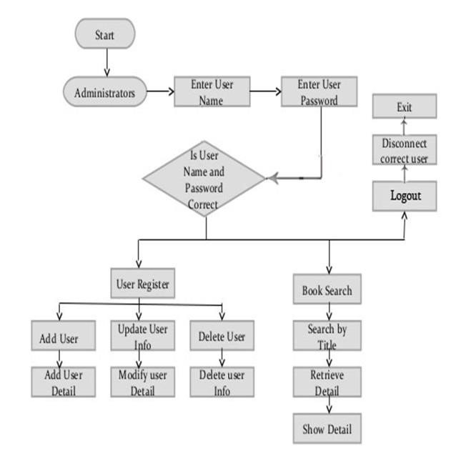

## Fig 3 : Module design

## CONCLUSION

### This paper predominantly addresses the enhancement of traditional library workflows, which typically involve manual processes characterized by slowness, inefficiency, low security, and challenging management. The proposed solution to these challenges is an online Library Management System, automating and digitizing the entire process. Our application is Java-based and integrates with a relational database (SQL). The frontend is developed using Java and its packages, including AWT and Swing, while the backend is supported and connected to the database using Java, its libraries, and APIs.

### By transitioning to an online system, the workload of the library can be significantly streamlined, leading to improved efficiency and security. The frontend provides a user-friendly interface, while the backend ensures seamless connectivity with the database, enabling efficient data management. As the library's workload evolves, new features can be incorporated into the existing application, ensuring its relevance and adaptability for future needs.

### Future Scope

Looking ahead, the application has the potential for extensive growth by incorporating additional features and facilities. As the number of students, books, and overall complexity increases, there may arise a need to migrate the library data from a local database to the cloud. This transition can be facilitated by making the necessary adjustments to the software application.

Leveraging cloud technology offers several advantages, including data backup facilities, remote updating and syncing of files, enhanced data security, and lifetime storage. Furthermore, the application could evolve to include features such as online lectures, a repository for previous year examination papers, videos, and an assignment submission section. Teachers could record and upload lecture videos, enriching the educational content available. To enhance collaboration and communication, a group chat function might be integrated into the application, enabling students to share concerns and doubts. This would contribute to a more interactive and beneficial environment for academic institutions. The flexibility of cloud-based solutions opens up numerous possibilities for continuous improvement and adaptation to evolving needs.

## REFERENCE

[1].HonghaiKan,Zhimin Yang, Yue Wang, Nana Qi, “Research on Library Management System for CDs Attached to Books Based on Cloud Computing”, in Proceedings of the 14th International Conference on Computer Supported Cooperative Work in Design 2010.

[2].Bao Sun, JiangweiFeng and Ling Liu, “A Study on How to Construct the Prediction Model of Library Lending of University Library”, International Conference on Information Science and Technology March 26-28, 2011 Nanjing, Jiangsu, China.

[3].Erxiang Chen,Minghui Liu,“Research and Design on Library Management System Based on Struts and Hibernate Framework”, WASE International Conference on Information Engineering2009.

[4].JianhuZheng, YunqingFeng, Yun Zhao, “A Unified Modeling Language-Based

Design and Application for a Library Management Information System”, in cybernetics and information technologies.

[5].Michael Hitchens, Andrew Firmage,“The Design of a Flexible Class Library Management System”, in IEEE conference 1998.

[6].WeihongYang,“Design and Implementation of Library Management System”,

International Conference on Management Science and Innovative Education (MSIE 2015).

[7].Bretthauer, D. “Open source software in libraries. Library Hi Tech News, 18 (5), 8-9(2001).

[8].Barve, S., &Dahibhate, N. B.,“Open source software for library services”, DESIDOC Journal of Library & Information Technology, 32(5)(2012).

[9].Albee, B. & Chen, Hsin-liang, “Public library staff’s perceived value and satisfaction of an open source library system”. Electronic Library, 32(3),

39.-402(2014).

[10].Singh, V.,“Expectation versus experience: librarians using open sourceintegrated library systems”, The Electronic Library, 32 (5), 688-709(2014).

[11]. Ching-yu Huang and Patricia A.,“MorrealeA Web-based, Self-Controlled

Mechanism to Support Students Learning SQL” IEEE Integrated STEM Education Conference (ISEC)2016.